


A Project Report Submitted in the partial fulfillment of the requirements for the award of the degree of

BACHELOR OF TECHNOLOGY
In
DEPARTMENT OF COMPUTER SCIENCE AND INFORMATION TECHNOLOGY
By

Duddukuri Sri Tanmai 2520080042
Sahasra 2520080062
Valaboju Akshitha 2520080003

Under the Esteemed Guidance of Khaja Shareef
CSIT HOD

Department of Computer Science and Information Technology



K L (Deemed to be) University

DEPARTMENT OF COMPUTER SCIENCE AND INFORMATION TECHNOLOGY

Declaration

We hereby declare that the project entitled “Sign Language Translator App – SignEase” is our original work carried out as part of the academic requirements of our course.
We declare that this project has been developed by us under the guidance of our project guide. The work presented in this report is based on our own efforts, implementation, and learning. We further declare that this project has not been submitted, either fully or partially, to any other institution or university for the award of any degree or academic qualification.
We have made every effort to acknowledge the resources, documentation, and references used during the development of this project.

D.Sri Tanmai - 2520080042
Sahasra -2520080062
V.Akshitha - 2520080003


K L (Deemed to be) University
DEPARTMENT OF COMPUTER SCIENCE AND INFORMATION TECHNOLOGY

CERTIFICATE

This is to certify that the project report entitled “Sign Language Translator App – SignEase” is a bonafide work done and submitted by [Tanmai] – [2520080042] , [Sahasra] – [2520090042] and [Akshitha] – [2520080003] in partial fulfillment of the requirements of the course DATABASE SYSTEMS ENGINEERING AND DISTRIBUTED BACKEND DEVELOPMENT (25CS1302E), Section 12, Team 22, at KLH University during 2026–2027, Trimester 4.
The project has been carried out under the guidance and supervision of the undersigned and is submitted in partial fulfillment of the academic requirements of the course.

Signature of the Guide

Signature of the Course Coordinator Signature of the HOD

ACKNOWLEDGEMENT

The successful completion of the project “Sign Language Translator App – SignEase” would not have been possible without the valuable support, guidance, and encouragement of many people. We would like to express our sincere gratitude to everyone who assisted us directly or indirectly in the completion of this project.
We express our deepest appreciation to our Course Coordinator, Dr. Khaja Shareef, and our project guide, Divya Priya Degala, Department of Computer Science and Information Technology, for their tremendous support, encouragement, valuable suggestions, and guidance throughout the development of this project.
We express our gratitude to Dr. Kaja Shareef, Head of the Department of Computer Science and Information Technology, for providing us with the necessary facilities, resources, and support that enabled us to successfully complete this project-based lab.
We also extend our sincere thanks to all the teaching and non-teaching staff members of the department for their assistance and cooperation throughout the project.
Finally, we sincerely thank our parents, friends, and classmates for their constant support, encouragement, and cooperation during the development and completion of our project.
Thank You.

Tanmai 2520080042
Sahasra 2520080062
V.Akshitha - 2520080003
Abstract

SignEase is a web-based Sign Language Translator application designed to support communication between people who use sign language and people who may not understand it. Communication barriers can make everyday interactions difficult, especially in educational, public, and social environments. SignEase aims to provide a simple and accessible interface through which users can explore sign-language gestures and convert selected signs into text and speech.
The application includes a user-friendly dashboard, a sign dictionary, a learning section, translation history, favorites, and a translator interface. The prototype uses HTML, CSS, and JavaScript to build the frontend. Browser-based features such as camera access and speech synthesis are used to support the demonstration. LocalStorage is used to maintain selected information in the browser.
The current prototype demonstrates the application workflow using predefined demo recognition rather than a trained machine-learning model. Future development can integrate computer vision and machine learning for gesture recognition, along with a backend and database for secure user accounts and persistent records. SignEase aims to make sign-language learning and communication support more accessible through a simple web application.

Index
S.No. | Chapters | Topics | Page No.
 |  | Acknowledgement
 |  | Abstract
1 | Introduction |  | 5
  1.1 Background of the Project
  1.2 Problem Statement
  1.3 Scope of the Project
  1.4 Objectives
  1.5 Importance of the Application
  1.6 Target Users / Audience
2 | System Requirements | - Hardware Requirements  - Software Requirements  - Development Tools and Frameworks | 7
3 | Technology Stack | - Frontend  - Backend  - Database  - Version Control  - Authentication and Security Libraries | 8
4 | System Architecture | - High-Level Architecture Diagram  - Description of Each Layer  - Deployment Architecture | 9
5 | Design | - Database Design Principles  - ER Diagram / Database Schema  - Design Decisions and Assumptions | 10
6 | Implementation | - Module-wise Implementation  - Front-end Logic  - API Integration  - Authentication and Authorization | 12
7 | Features | - List of Main Features  - How Each Feature Works | 13
8 | Testing | - Postman API Testing  - Integration Testing  - Tools Used for Testing  - Test Cases and Results | 15
9 | Deployment | - Steps to Deploy  - Environment Configuration  - Hosting of Frontend and Backend | 17
10 | Challenges & Limitations | - Issues Faced During Development  - Solutions Applied  - Current Limitations or Known Bugs | 18

S.No. | Chapters | Topics | Page No.
11 | Future Enhancements | - Planned Features  - Possible Integrations or Optimizations | 19
12 | Conclusion | - Summary of the Project  - What Was Achieved  - Skills Learned | 20
13 | References | Documentation, tools, and resources used | 21
14 | Appendices | Sample Code Snippets Installation / Setup Instructions Default Login Credentials  API Reference Summary  Screenshots (to be added by the student) | 22

CHAPTER -1 INTRODUCTION

Background of the Project
Communication plays an important role in education, employment, social interaction, and everyday activities. People who communicate using sign language may experience difficulties when interacting with individuals who are unfamiliar with sign language. This communication gap can make simple interactions more difficult and may reduce accessibility in different environments.
Sign language communicates information through hand gestures, movements, facial expressions, and body language. Although sign language is an effective communication method, learning and understanding it requires practice and appropriate resources.
With the development of web technologies, applications can be created to provide accessible tools for learning and communication. A web-based application can allow users to explore signs, understand their meanings, and practise common gestures through an interactive interface.
SignEase – Sign Language Translator App is proposed as a web-based solution to support sign-language learning and translation demonstrations. The application provides multiple modules through a centralized interface and is designed to be simple and easy to use.
The current prototype demonstrates the frontend workflow of a sign-language translation system. It provides camera access and demo translation functionality while preparing the application architecture for future integration with computer vision and machine-learning technologies.

Problem Statement
People who use sign language can face communication barriers when communicating with individuals who do not understand sign language. In many situations, communication may depend on another person who understands the signs.
Learning sign language can also be difficult when users do not have access to organized learning resources. Existing resources may be distributed across different platforms, making it difficult for beginners to learn and practise common signs in one place.
The proposed SignEase application aims to provide a centralized and user-friendly platform for exploring sign-language gestures, displaying their meanings, and supporting text and speech output.
The long-term objective is to enable real-time sign recognition using a camera and machine-learning model.

Scope of the Project

The scope of SignEase includes:

Development of a web-based sign-language application.

User-friendly landing page and dashboard.

Sign translation interface.

Camera access through the browser.

Demo sign-to-text translation.

Text-to-speech output.

Sign dictionary.

Learning section.

Translation history.

Favorite signs.

User profile interface.

Feedback interface.

Responsive frontend design.

Preparation for future machine-learning integration.

The current project primarily focuses on the frontend prototype. A trained ML model, centralized backend, and production database can be integrated in future versions.

Objectives

The main objectives of the project are:
- To develop a simple and user-friendly Sign Language Translator application.
- To provide an interface for demonstrating sign-to-text translation.
- To provide camera access for future real-time sign recognition.
- To convert translated text into speech.
- To provide a sign dictionary for learning and reference.
- To provide a learning module for beginners.
- To maintain translation history.
- To allow users to save frequently used signs as favorites.
- To develop an accessible and responsive web interface.
- To create a foundation for future machine-learning and database integration.

Importance of the Application

SignEase is important because it addresses a communication and accessibility problem through technology. A digital application can provide users with easy access to sign-language-related information and learning resources.
The application can help users become familiar with common signs and understand how gestures can be represented as text and speech.
It also demonstrates how web technologies, browser APIs, and future machine-learning technologies can be combined to develop accessibility-focused applications.

Target Users / Audience

The main target users of SignEase include:
- People interested in learning sign language.
- People who communicate using sign language.
- Students.
- Teachers and educators.
- Individuals interacting with sign-language users.
- Accessibility-focused organizations.
- Developers and researchers interested in gesture recognition.

CHAPTER 2: SYSTEM REQUIREMENTS

Hardware Requirements

The application has relatively simple hardware requirements because the current version is a web-based frontend application.

Recommended hardware includes:

Laptop or desktop computer.

Minimum 4 GB RAM.

Dual-core processor or better.

Webcam or built-in camera for translator testing.

Speakers or headphones for speech output.

Keyboard and mouse/touchpad.

Sufficient storage for project files.

Internet connection for development resources and future integrations.

Software Requirements
The software requirements are:
- Windows, Linux, or macOS operating system.
- Visual Studio Code.
- Google Chrome, Microsoft Edge, or Mozilla Firefox.
- HTML5 support.
- CSS3 support.
- JavaScript support.
- Browser support for MediaDevices API.
- Browser support for Web Speech API.
- Live Server extension for convenient local development.

Development Tools and Frameworks

The project uses the following development tools and technologies:
- Visual Studio Code: Main code editor.
- HTML5: Application structure.
- CSS3: Application styling and responsive layout.
- JavaScript: Application logic and interaction.
- MediaDevices API: Camera access.
- Web Speech API: Text-to-speech functionality.
- LocalStorage: Browser-based storage for demo information.
- Git/GitHub: Can be used for version control and project collaboration.

CHAPTER 3: TECHNOLOGY STACK

Frontend
The frontend of SignEase is developed using HTML5, CSS3, and JavaScript.
HTML5 defines the structure of the application. CSS3 is used to create the visual design, layouts, buttons, cards, forms, and responsive interface. JavaScript provides interactive functionality and controls application behavior.
The frontend contains multiple sections including the landing page, authentication interface, dashboard, translator, dictionary, history, favorites, learning section, profile, and feedback

Backend
The current SignEase prototype does not contain a connected backend server.
The application performs its current demonstration functionality directly in the browser. Future development can introduce a backend using technologies such as Node.js and Express.js.
A backend can provide APIs for user authentication, sign management, history, favorites, feedback, and learning progress.

Database

The current prototype uses LocalStorage for selected demo information. LocalStorage allows information such as favorites and history to remain available within the same browser.

For a complete DBMS implementation, a centralized database can be added in future development.

Possible database options include:

MySQL

PostgreSQL

MongoDB

A future database can contain entities such as Users, Signs, Categories, Translation History, Favorites, Lessons, User Progress, and Feedback.

Version Control

Git can be used as the version-control system for SignEase. Git allows developers to track changes to source code and maintain different versions of the project.

GitHub can be used to store the project repository and support collaboration between team members.

Authentication and Security Libraries

The current frontend prototype provides login and registration interfaces but does not implement complete backend authentication.

For a production version, authentication can be implemented using secure backend authentication methods.

Passwords should be stored using secure hashing algorithms such as bcrypt rather than plain text. Authentication tokens such as JWT can be used for maintaining secure sessions.

User input should also be validated and sensitive information should never be exposed through frontend code.

CHAPTER 4: SYSTEM ARCHITECTURE

High-Level Architecture Diagram
The Sign Language Translator App – SignEase follows a layered architecture that separates the user interface, application logic, and data storage. This structure makes the application easier to develop, maintain, and extend with advanced technologies such as machine learning, computer vision, backend services, and a centralized database.The architecture consists of three main layers: Presentation Layer, Application/Logic Layer, and Data Layer.
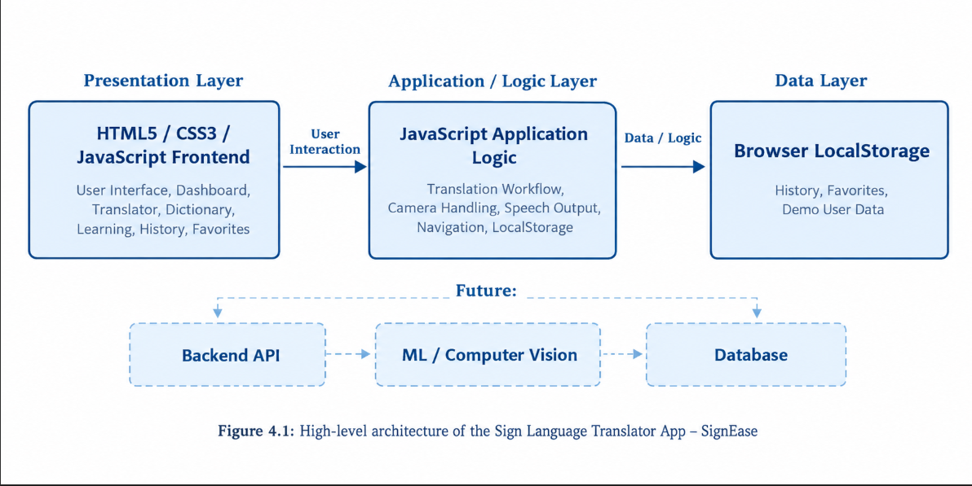

Description of Each Layer

Presentation Layer
The presentation layer contains the user interface. It is developed using HTML and CSS and provides navigation and visual components for the user.

Application Logic Layer
JavaScript handles application interactions, navigation, translation demonstration, favorites, history, and communication with browser APIs.

Browser API Layer
The MediaDevices API provides camera access, while the Web Speech API provides speech synthesis.

Local Storage Layer
LocalStorage is used to maintain selected demo data such as history and favorites.

Future Backend Layer
A future backend can process API requests, manage authentication, communicate with the database, and connect the frontend with the ML model.

Future Database Layer
A database can provide persistent storage for users, signs, history, favorites, lessons, and other application data.

Deployment Architecture

he current prototype can run on a local computer using a modern web browser.
During development, Visual Studio Code and a local development server can be used to run the application.
In a future deployment, the frontend can be hosted on a web server or cloud platform, while the backend API and database can be deployed separately.

CHAPTER 5: DESIGN

Database Design Principles

Although the current prototype uses LocalStorage, a future database design for SignEase should follow standard DBMS principles.

The database should:

Use primary keys for unique identification.

Use foreign keys for relationships.

Reduce duplicate information through normalization.

Validate important data.

Maintain referential integrity.

Protect sensitive user information.

Separate user information from application content.

Maintain timestamps for important records.

ER Diagram / Database Schema

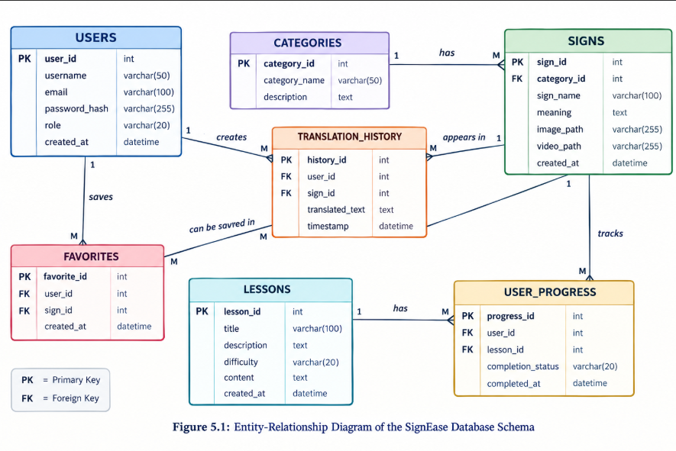

The database follows a relational structure in which each entity has a unique primary key. Foreign keys are used to establish relationships between related tables. For example, category_id in the SIGNS table connects each sign with its corresponding category, while user_id and sign_id in TRANSLATION_HISTORY identify the user and sign associated with a translation.

The FAVORITES table acts as a relationship table between users and signs, allowing multiple users to save the same sign while each user can maintain their own collection of favorite signs.

The USER_PROGRESS table connects users with lessons and allows the system to track learning activity.

This structure reduces unnecessary duplication of data and provides a foundation for implementing a centralized database in the future.

Design Decisions and Assumptions

The project is designed as a web application so that users can access it through a browser without installing a dedicated application.
HTML, CSS, and JavaScript were selected because they provide a simple and flexible platform for frontend development.
The current translator uses demo/predefined recognition rather than a trained ML model. This allows the frontend workflow to be demonstrated before implementing the computationally more complex recognition system.
LocalStorage is used for prototype-level data persistence. A centralized database will be required for multi-user access and permanent stora

CHAPTER 6: IMPLEMENTATION

Module-wise Implementation

Landing Page

The landing page introduces SignEase and provides information about the application's purpose and features.

Login and Registration

The authentication interface provides forms through which users can enter their account information. Complete server-side authentication is planned for a future version.

Dashboard

The dashboard acts as the main navigation area and provides access to different application modules.

Translator

The translator module provides a camera interface and translation output area. The current version demonstrates the translation workflow using predefined/demo recognition.

Sign Dictionary

The dictionary displays signs and their meanings so that users can explore and learn common gestures.

Learning Module

The learning module provides content for users who want to practise sign language.

History

The history section displays previous demo translation activities stored in LocalStorage.

Favorites

The favorites section provides access to signs saved by the user.

Profile

The profile section displays user-related information.

Feedback

The feedback section provides an interface for users to submit comments or suggestions.

Front-end Logic

The frontend logic is implemented using JavaScript.

JavaScript handles:

Navigation.

Button interactions.

Form interactions.

Demo translation.

Camera initialization.

Speech output.

Favorites.

Translation history.

LocalStorage operations.

Dynamic content updates.

CSS provides the visual styling and responsive layout.

API Integration
The current prototype does not use a custom REST API.
It uses browser-provided APIs including:
MediaDevices API: Used to request camera access.
Web Speech API: Used to convert translated text into speech.
Future versions can use REST APIs to connect the frontend to a backend and database

Authentication and Authorization

The current prototype provides the user interface for login and registration. Complete authentication and authorization require backend implementation.
A future implementation can use:
- Password hashing.
- JWT-based authentication.
- Role-based authorization.
- Input validation.
- Secure session management.
Possible roles include User and Administrator.

CHAPTER 7: FEATURES

List of Main Features
The major features of SignEase are:
- Landing page.
- User registration interface.
- Login interface. B
- Dashboard.
- Sign translator.
- Camera access.
- Demo sign recognition.
- Text translation output.
- Speech output.
- Sign dictionary.
- Translation history.
- Favorite signs.
- Learning module.
- User profile.
- Feedback interface.
- Responsive user interface.

How Each Feature Works

Sign Translator
The user opens the translator module and interacts with the translation interface. The current prototype demonstrates translation using predefined/demo signs.

Camera Access
The application requests permission to access the user's camera through the browser. The camera provides the input interface required for future gesture-recognition functionality.

Text Output
After a demo sign is selected or recognized through the prototype workflow, the corresponding meaning is displayed as text.

Speech Output
The translated text can be converted into speech using the browser's Web Speech API.

Sign Dictionary
The dictionary contains signs and their meanings, allowing users to search or explore common signs.

History
Previous demo translations can be displayed in the history section. LocalStorage can be used to retain this information.

Favorites
Users can save frequently used signs and access them from the favorites section.

Learning Module
The learning section provides structured sign-language-related learning content.f

Profile
The profile section allows users to view their profile-related information.

Feedback
Users can provide feedback and suggestions through the feedback interface.

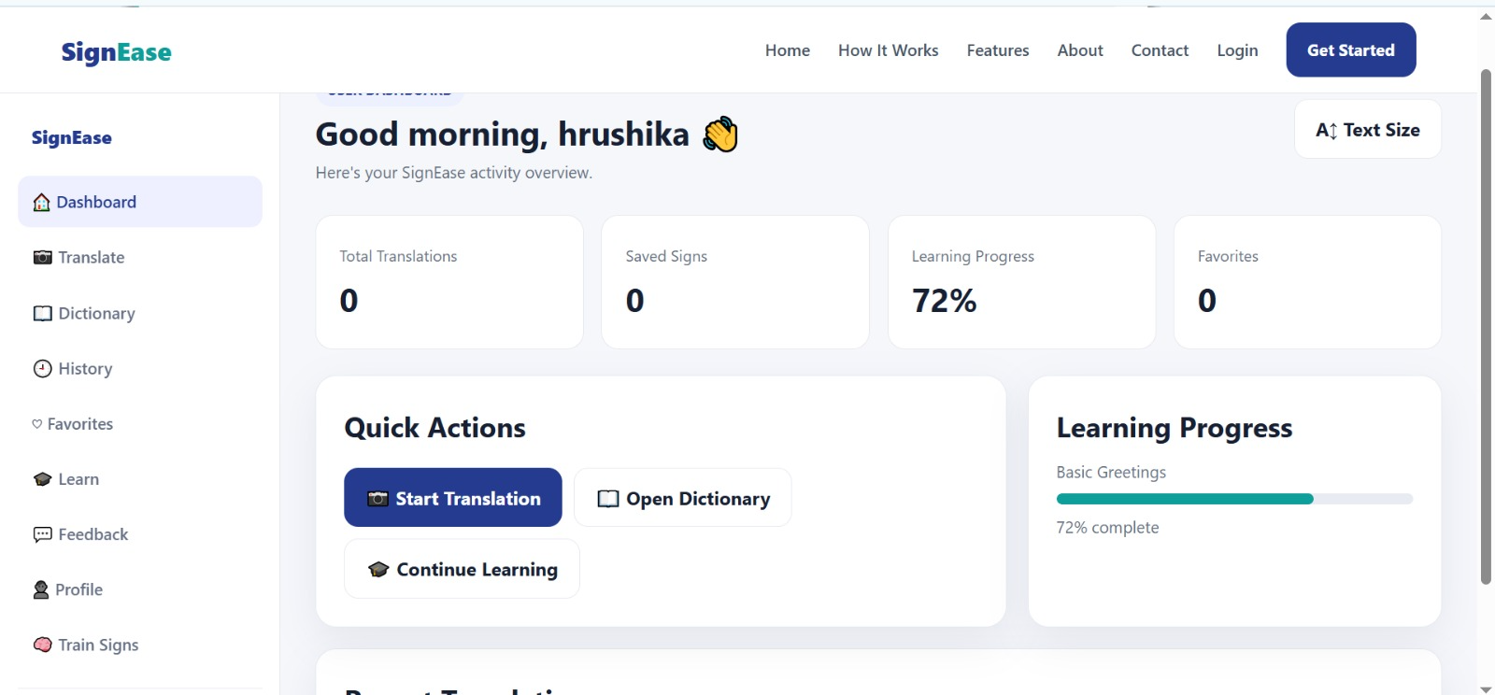

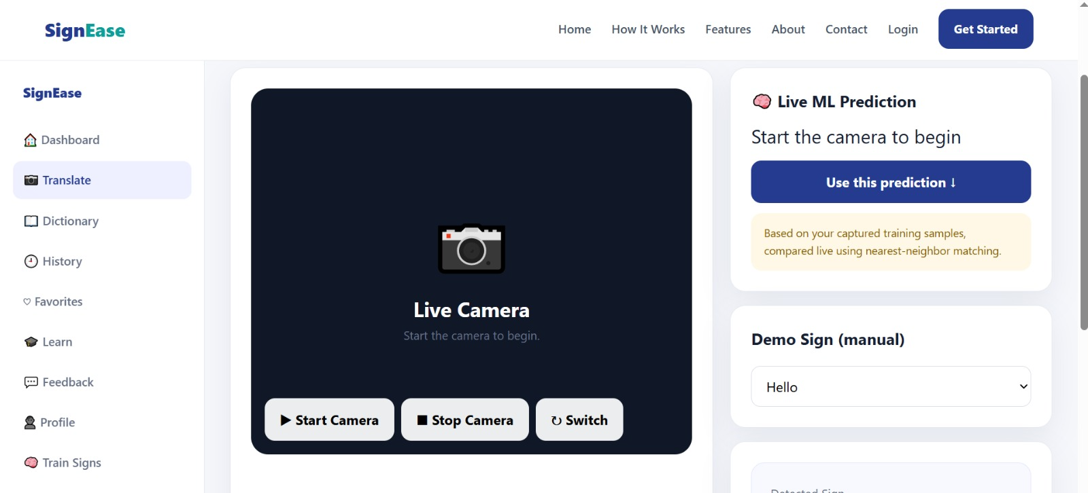

CHAPTER 8: TESTING

8.1 Functional Testing

Functional testing is performed to verify whether each module works according to its intended purpose.

The following areas should be tested:

Page navigation.

Buttons.

Forms.

Translator interface.

Camera permission.

Demo translation.

Speech output.

Dictionary.

Favorites.

History.

Learning module.

Profile.

Feedback.

Integration Testing

Integration testing verifies whether different components work together correctly.

Examples include:

Translator + camera access.

Translator + text output.

Text output + speech synthesis.

Favorites + LocalStorage.

History + LocalStorage.

Dashboard + application modules.

Tools Used for Testing
    - Postman manual and scripted API testing
    - curl (command line) scripted regression testing across every phase of development
    - MySQL command-line client direct verification of table contents and constraint behavior
    - Manual browser testing verifying the React frontend's behavior and appearance

Test Cases and Results
A representative sample of the test cases executed, drawn from the project's actual test log, is summarized below.

# | Test Case | Expected Result | Actual Result
1 | Open SignEase | Landing page loads successfully | Pass
2 | Open Login | Login interface is displayed | Pass
3 | Open Registration | Registration interface is displayed | Pass
4 | Open Dashboard | Dashboard loads correctly | Pass
5 | Open Translator | Translator interface appears | Pass
6 | Request camera access | Browser asks for camera permission | Pass
7 | Allow camera | Camera stream becomes available if supported | Pass

8 |  | Select demo sign | Corresponding text is displayed | Pass
9 |  | Click speech button | Translated text is spoken | Pass
10 |  | Open dictionary | Sign information is displayed | Pass
11 |  | Add favorite | Selected sign is saved | Pass
12 |  | Open history | Previous demo translations are displayed | Pass
13 |  | Refresh page | LocalStorage data remains where implemented | Pass
14 |  | Open learning | Learning section is displayed | Pass
15 |  | Open profile | Profile section is displayed | Pass
16 |  | Submit feedback | Feedback interface accepts user input | Pass

CHAPTER 9: DEPLOYMENT

Steps to Deploy
The current SignEase frontend can be deployed locally using Visual Studio Code.

Steps:
- Install Visual Studio Code.
- Open the SignEase project folder.
- Open the main HTML file.
- Install the Live Server extension if required.
- Right-click the HTML file.
- Select Open with Live Server.
- The application opens in a browser.
- Allow camera permission when testing the translator.
- Test all modules.

Environment Configuration

The current prototype does not require a backend server or database configuration.

The main requirements are:

Modern web browser.

Camera permission.

JavaScript enabled.

Local development server where required.

Future backend implementation will require environment variables for database credentials, authentication secrets, API configuration, and other sensitive settings.

Hosting of Frontend and Backend

The current prototype can be hosted as a static web application.
Possible future deployment architecture:
Frontend → Web Hosting
Backend → Application Server
Database → Database Server
ML Model → ML/Inference Service
These components can communicate through secure APIs

CHAPTER 10: CHALLENGES & LIMITATIONS

Issues Faced During Development
Several challenges were encountered or considered during the development of SignEase.
The first challenge was designing an interface that could contain multiple modules without making navigation complicated.
Another challenge was handling camera access through browser permissions. Different browsers and devices may behave differently when requesting camera access.
Speech output also depends on browser support and the available speech synthesis voices.
Another major challenge is real-time sign recognition. Accurate sign recognition requires image processing, hand detection, feature extraction, and a trained machine-learning model.

Solutions Applied
A modular interface was designed to organize the different sections of the application.
Browser APIs were used for camera access and speech synthesis instead of requiring external services for the basic prototype.
LocalStorage was used to demonstrate client-side persistence for history and favorites.
The translator was initially implemented using predefined/demo recognition so that the complete user interface and workflow could be demonstrated before integrating an ML model.

Current Limitations or Known Bugs
The current project has the following limitations:
- Real-time machine-learning sign recognition is not yet implemented.
- The translator currently uses predefined/demo recognition.
- There is no connected backend server.
- There is no centralized database in the current prototype.
- Login and registration are interface-level features unless connected to a backend authentication system.
- LocalStorage data is limited to the browser/device.
- Translation accuracy cannot be evaluated until a trained ML model is integrated.
- Camera functionality depends on browser permissions and device availability.
- Speech synthesis depends on browser support and available voices.
- Continuous sentence-level sign recognition is not currently implemented.

CHAPTER 11: FUTURE ENHANCEMENTS

Planned Features

Future versions of SignEase can include:

Real-time sign-language recognition.

Machine-learning-based gesture classification.

Computer vision-based hand tracking.

Continuous sign sequence recognition.

Sentence-level translation.

Larger sign vocabulary.

Support for multiple sign languages.

Improved sign dictionary.

Video-based sign tutorials.

User learning progress.

Secure user authentication.

Backend database integration.

Admin management system.

Cloud-based deployment.

Improved mobile support.

Possible Integrations or Optimizations

Computer vision frameworks such as OpenCV and MediaPipe can be integrated to detect and track hand movements.
Machine-learning frameworks such as TensorFlow can be used to develop a gesture-classification model.
A backend using Node.js and Express.js can manage users and application data.
MySQL or MongoDB can be integrated for persistent data storage.
Performance can be improved by processing camera frames efficiently and reducing unnecessary model predictions.
A cloud deployment can allow users to access the application from different devices.

CHAPTER 12: CONCLUSION

Summary of the Project
SignEase is a web-based Sign Language Translator application designed to support sign-language learning and communication. The application provides a centralized interface containing translation, dictionary, learning, history, favorites, profile, and feedback features.
The project demonstrates how HTML, CSS, JavaScript, browser APIs, and LocalStorage can be combined to create an accessibility-focused web application.
The current prototype provides the foundation for a more advanced sign-language recognition system.

What Was Achieved

The project achieved the development of a functional frontend prototype containing:

SignEase landing page.

Login and registration interfaces.

Dashboard.

Translator interface.

Camera access.

Demo translation functionality.

Text output.

Speech output.

Sign dictionary.

Translation history.

Favorites.

Learning section.

Profile interface.

Feedback interface.

Responsive design.

Browser-based data persistence.

The project also establishes a clear architecture for future integration with machine learning, backend services, and a database.

Skills Learned

During the development of SignEase, the following skills were developed:
- HTML5 web development.
- CSS3 styling.
- JavaScript programming.
- Responsive web design.
- User interface design.
- Browser API integration.
- Camera access.
- Speech synthesis.
- LocalStorage.
- Database planning.
- ER diagram and schema design.
- Software testing.
- Project documentation.
- Understanding of machine-learning integration requirements.
- Accessibility-focused application development.

CHAPTER 13: REFERENCES

• MDN Web Docs – HTML
https://developer.mozilla.org/en-US/docs/Web/HTML
• MDN Web Docs – CSS
https://developer.mozilla.org/en-US/docs/Web/CSS
• MDN Web Docs – JavaScript
https://developer.mozilla.org/en-US/docs/Web/JavaScript
• MDN Web Docs – MediaDevices API
https://developer.mozilla.org/en-US/docs/Web/API/MediaDevices
• MDN Web Docs – Web Speech API
https://developer.mozilla.org/en-US/docs/Web/API/Web_Speech_API
• MDN Web Docs – Web Storage API
https://developer.mozilla.org/en-US/docs/Web/API/Web_Storage_API
• OpenCV Documentation
https://docs.opencv.org/
• MediaPipe Documentation
https://ai.google.dev/edge/mediapipe/solutions/guide
• TensorFlow Documentation
https://www.tensorflow.org/
• MySQL Documentation
https://dev.mysql.com/doc/
• Visual Studio Code Documentation
https://code.visualstudio.com/docs

CHAPTER 14: APPENDICES

Appendix A: Sample Code Snippet

Camera Access
async function startCamera() {
try {
const stream = await navigator.mediaDevices.getUserMedia({
video: true
});

const video = document.getElementById("camera");
video.srcObject = stream;
} catch (error) {
console.error("Camera access failed:", error);
}
}

Speech Output:
function speakText(text) {
if ("speechSynthesis" in window) {
const speech = new SpeechSynthesisUtterance(text);
window.speechSynthesis.speak(speech);
}
}

LocalStorage:
function saveFavorite(sign) {
let favorites =
JSON.parse(localStorage.getItem("favorites")) || [];

favorites.push(sign);

localStorage.setItem(
"favorites",
JSON.stringify(favorites)
);
}

Appendix B: Installation and Setup Instructions
Requirements
- Visual Studio Code.
- Modern web browser.
- Webcam for camera testing.
- Live Server extension.
Installation Steps
- Install Visual Studio Code.
- Create or open the SignEase project folder.
- Add the project HTML, CSS, and JavaScript files.
- Open the project in Visual Studio Code.
- Install the Live Server extension.
- Right-click the main HTML file.
- Select Open with Live Server.
- Open the generated local URL in the browser.
- Allow camera permission when requested.
- Test the different application modules.

Appendix C: Default Login Credentials

The current SignEase frontend prototype does not use a connected backend authentication system.

Therefore, there are no official database-backed default login credentials for the current version.

If a demo login has been configured in your actual HTML/JavaScript code, enter those exact credentials here.

Appendix D: API Reference Summary

The current prototype does not contain a custom REST API.
The following browser APIs are used:
API | Purpose
MediaDevices API | Provides access to the device camera
Web Speech API | Converts translated text into speech
LocalStorage API | Stores demo history and favorites
Future APIs can provide:
- User registration.
- User login.
- Sign management.
- Translation history.
- Favorites.
- Learning progress.
- Feedback.
- ML prediction requests.

Appendix E: Screenshots
Suggested screenshots, in order:
- Login Page

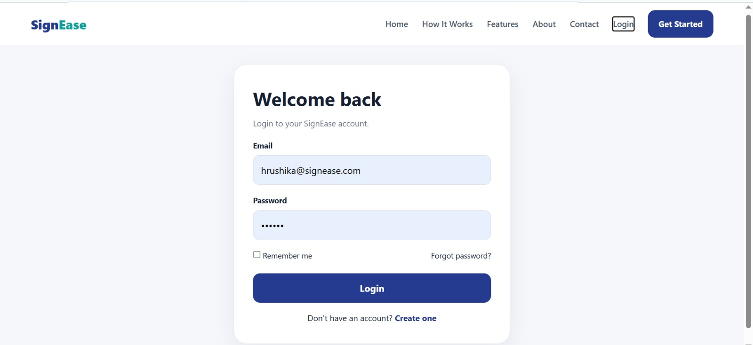
- Dashboard

- Registration

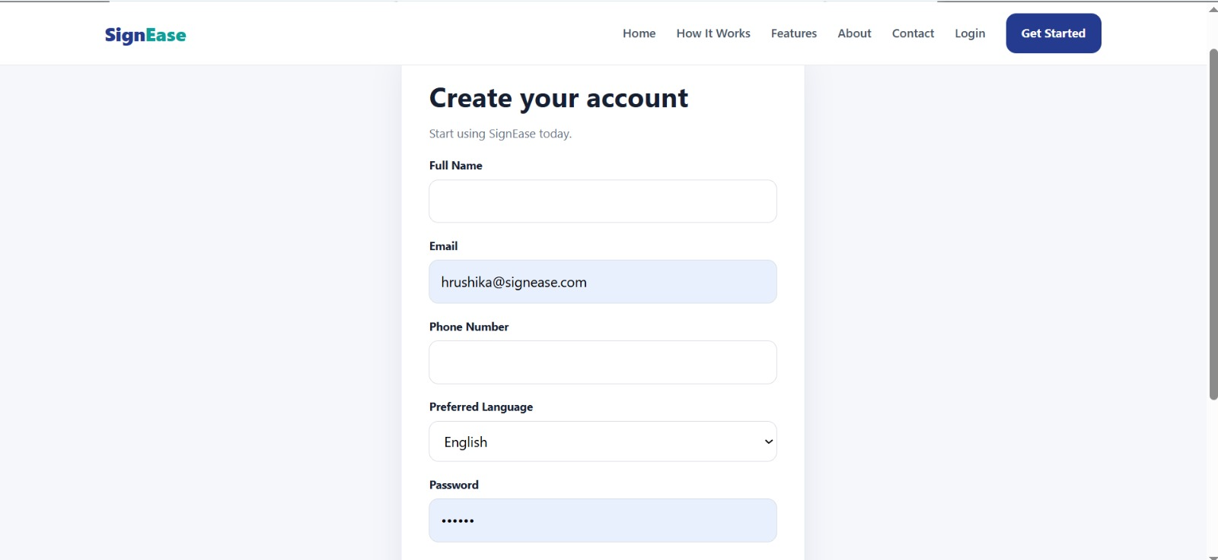

4.Translator

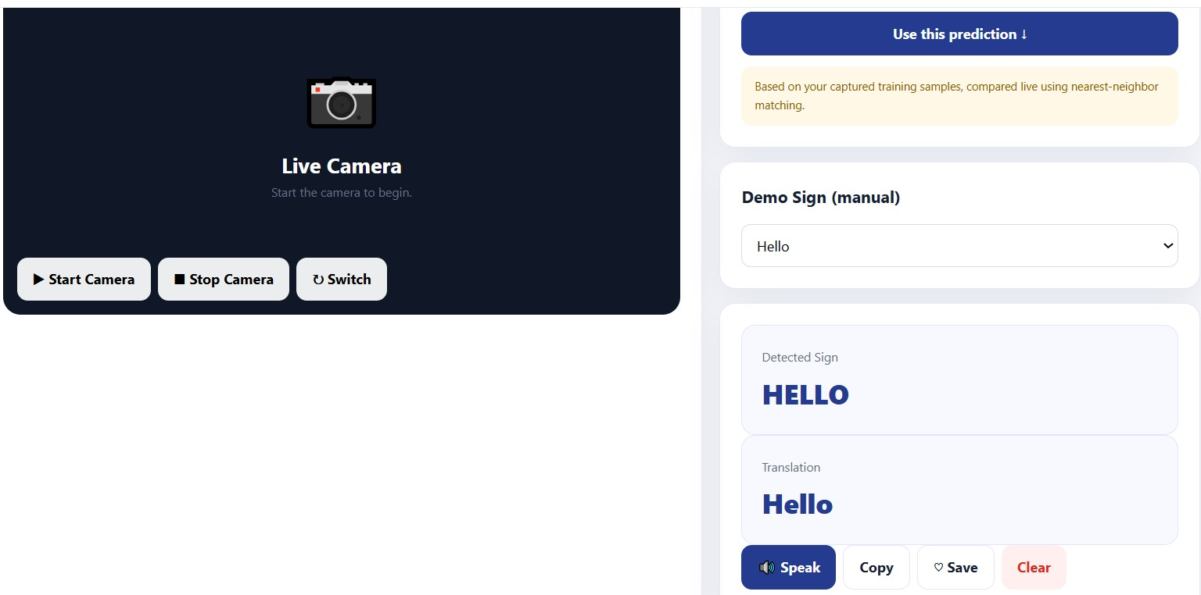

5.Translator Output

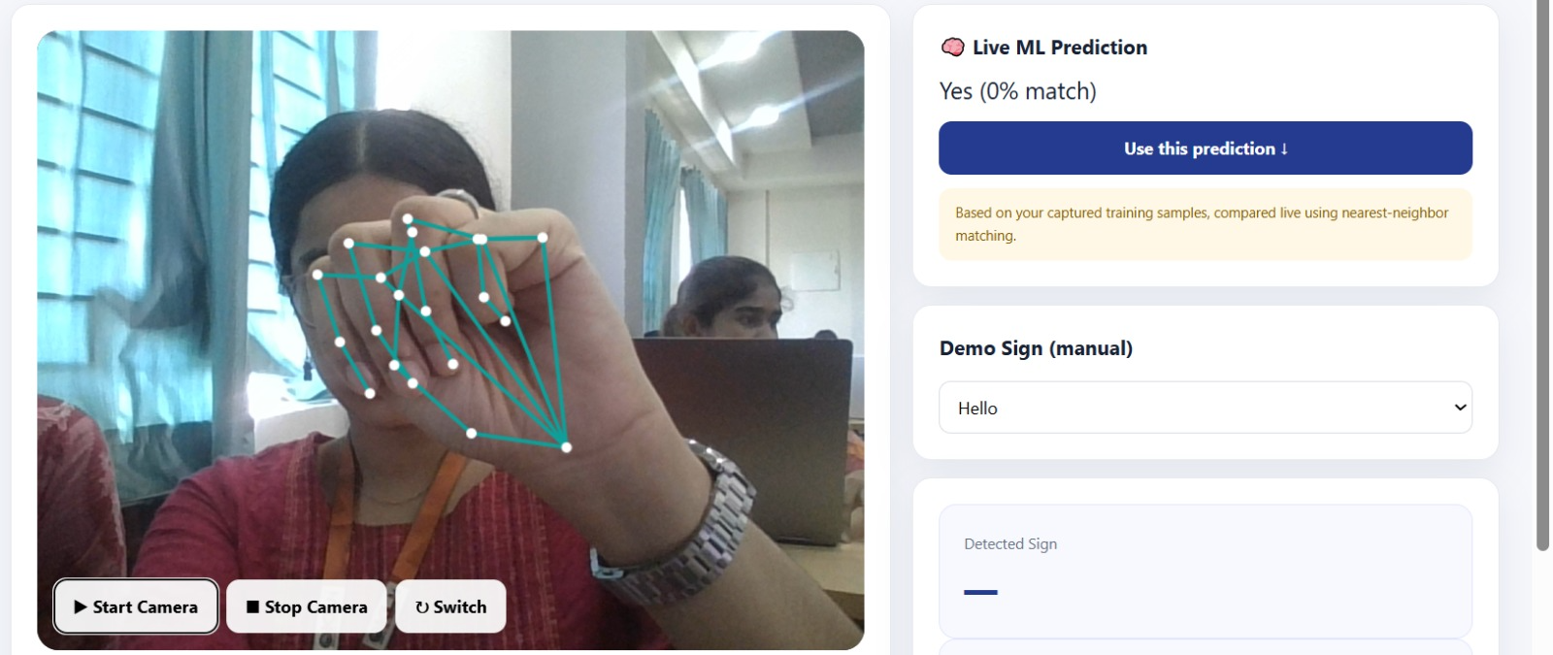

6. Sign Dictionary

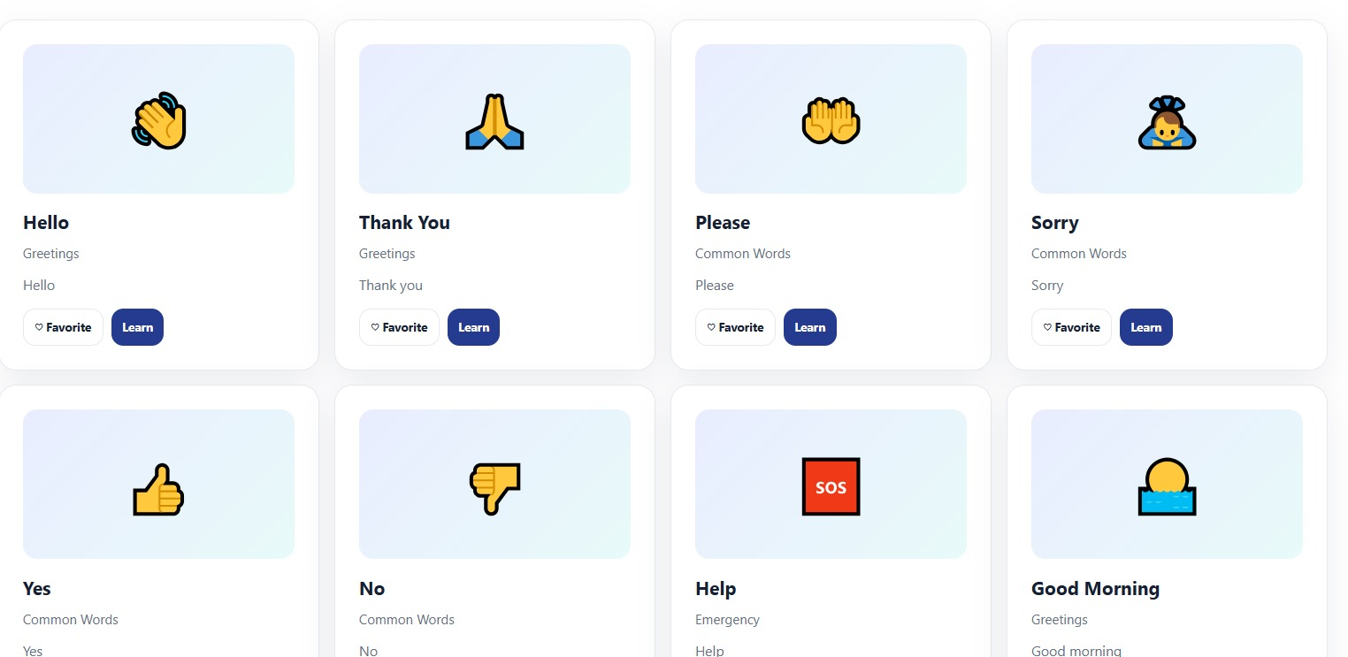

7.Profile

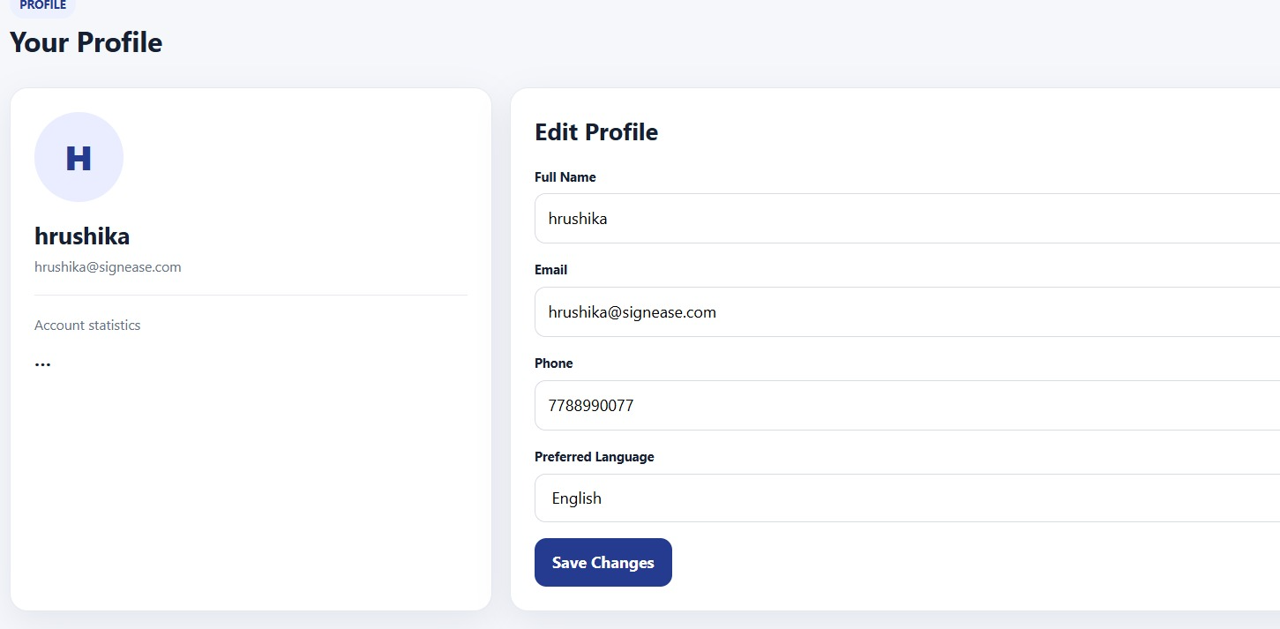

8.Feedback

